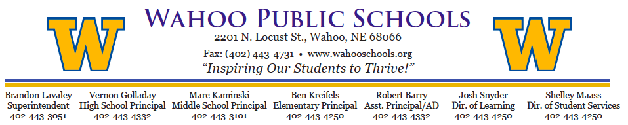

**WAHOO PUBLIC SCHOOL**

**PARENT PERMISSION FOR MEDICATION ADMINISTRATION**

Wahoo Public Schools 2201 North Locust, Wahoo, NE 68066

Elementary 402-443-4250 ~ Middle School 402-443-3101 ~ High School 402-443-4332

Wahoo Public School Fax 402-443-4731

I/We give Wahoo Public Schools permission to administer the medication below to my child and permission to contact my child’s health care provider concerning this medication or the condition for which it is prescribed.

Instructions:

1. All medications must be brought to school in the **original labeled container**.
2. Medications must be transported to and from school by an **adult**.
3. A **Doctor’s note** is required for all prescribed medications to be given at school.

Student Name:

Grade:

Medication & Dose:

Time Medication to be Given:

Why is medication being taken? (Diagnosis):

***This section is only required for prescribed medications:***

Doctor’s Name:

Name of Doctor’s Office:

Doctor Phone Number:

Doctor Fax Number:

Parent/Guardian will provide supplies for needed treatment, procedure and/or medication. Treatment, procedure and/or medication directions will be **renewed each school year and amended as necessary during the school year**. Student may be transported to local healthcare facilities if emergency treatment, procedure and/or medication is indicated or has been administered.

Parent Signature: Date:

Special Instructions: